Kafka duplicate transaction
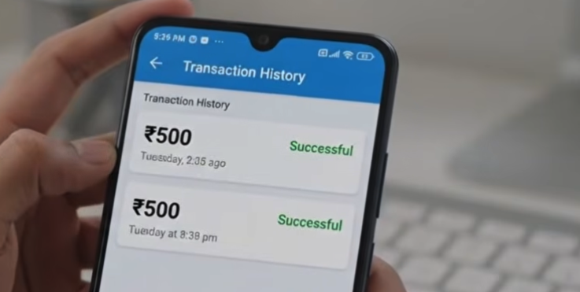

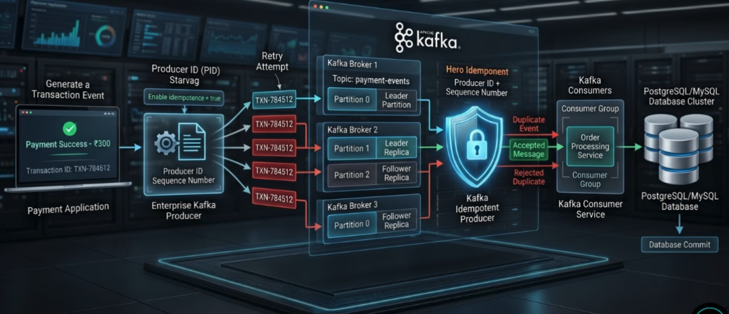

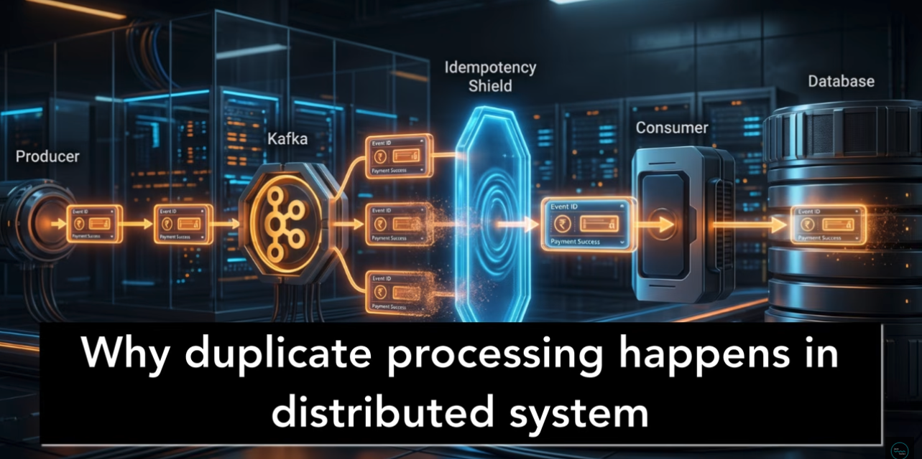
Something went wrong in the distributed system after DB update
Unless offset commit received, kafka retry to read same event again and again
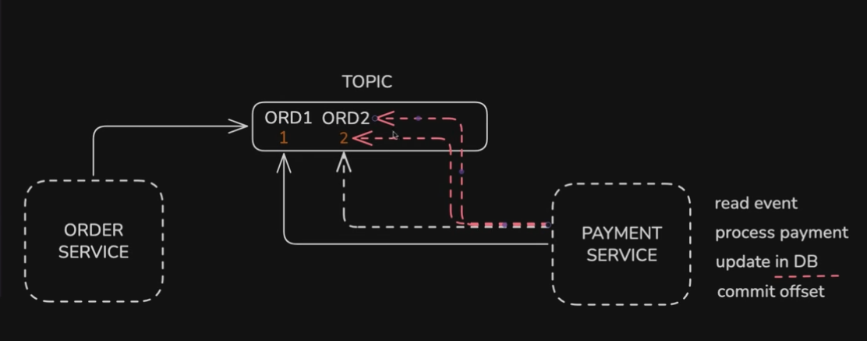
Kafka consumer provides at least one delivery.

Happy Path
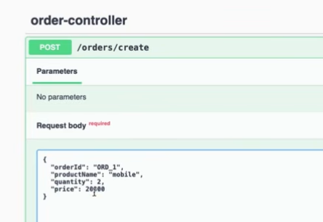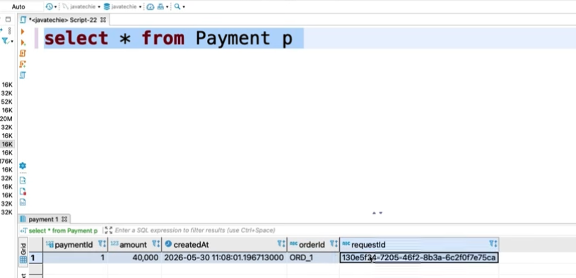
Before commit – in the consumer let us throw runtime exception
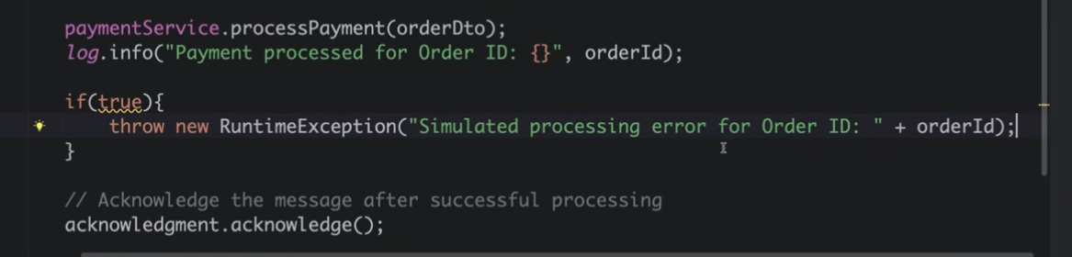

Now let us see failure scenario.
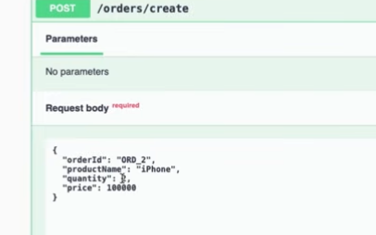
producer side no error
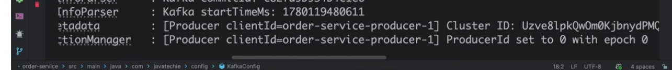
consumer side error
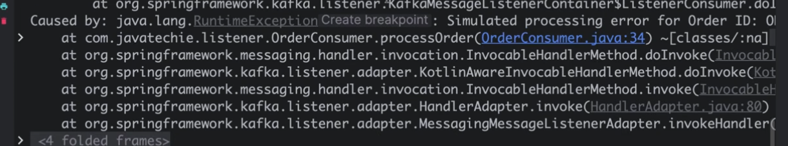
By default, it will try 10 time retry
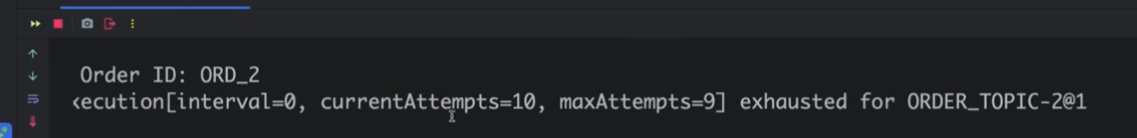
see duplicate transaction
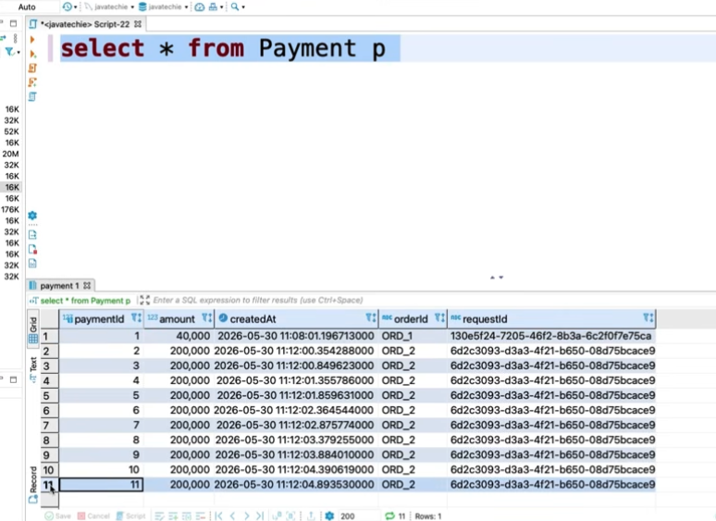
Now let us apply idempotency - check does the request already processed or not.
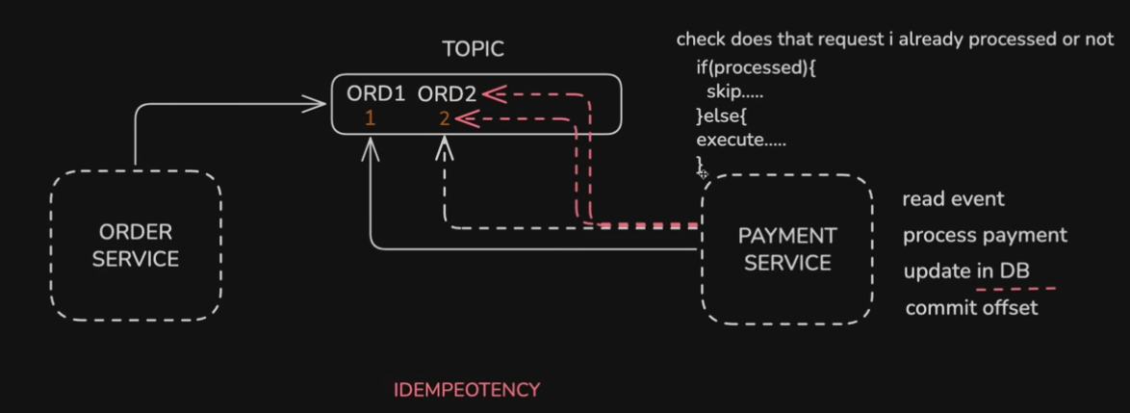
We can also maintain different idempotency table. / we can also apply unique id constraint for the payment table
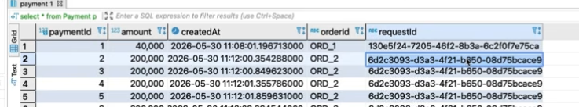
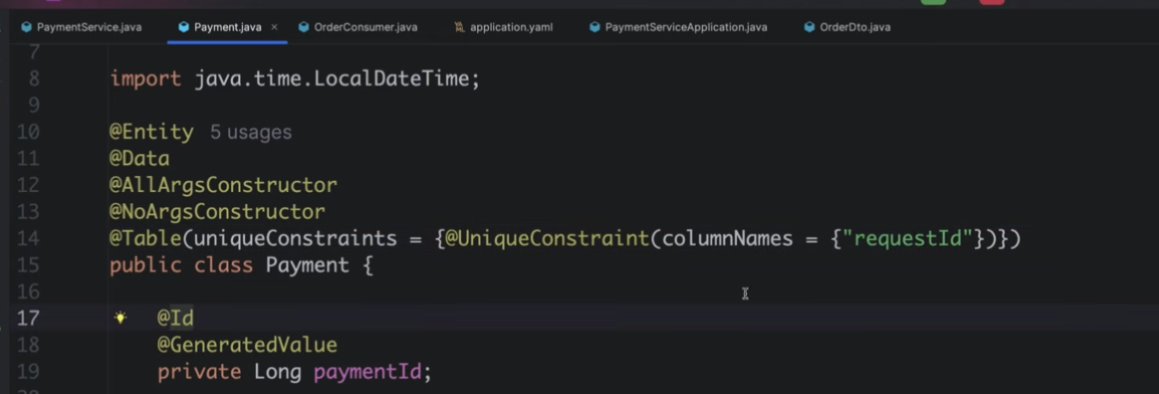
If we apply unique constraint we will get DataIntegrityViolationException so the following below coding
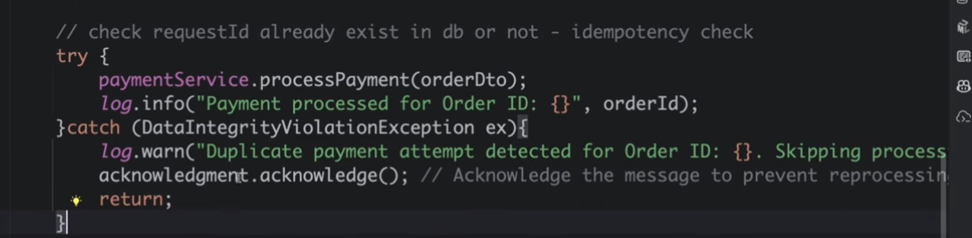
Another way in the consumer, we can do fetch and check request id already present or not if yes just return. Apply manual acknowledgement before return statement
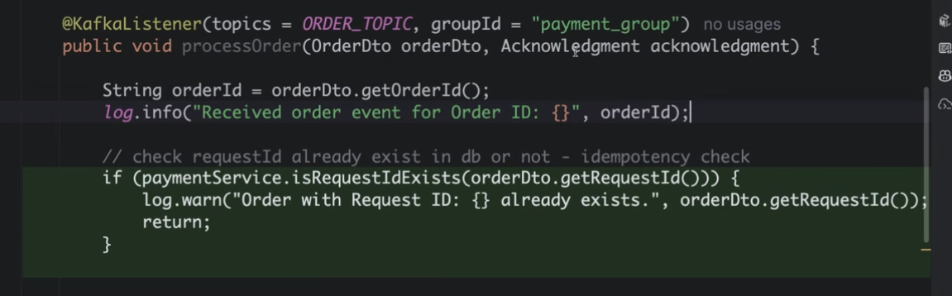
You will see duplicate entry message now.
